Assignment 1: AWS EC2 instance

In this we have to create a static web page with my name on it.

So, we need a linux instance and a web service (I will be using apache) to host the html created. So, these are the following steps:

1. I have to created an EC2 instance, so I selected launch instance in that I have selected Linux and then have further used default settings.
2. I have selected the following security group which had the required protocol’s, i.e. SSH , HTTP and HTTPS.

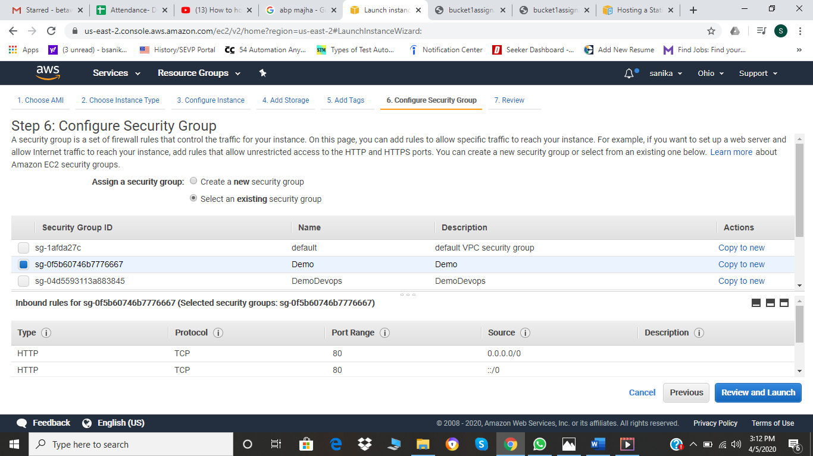

1. Next step is to review whatever we have selected settings are appropriate or not.

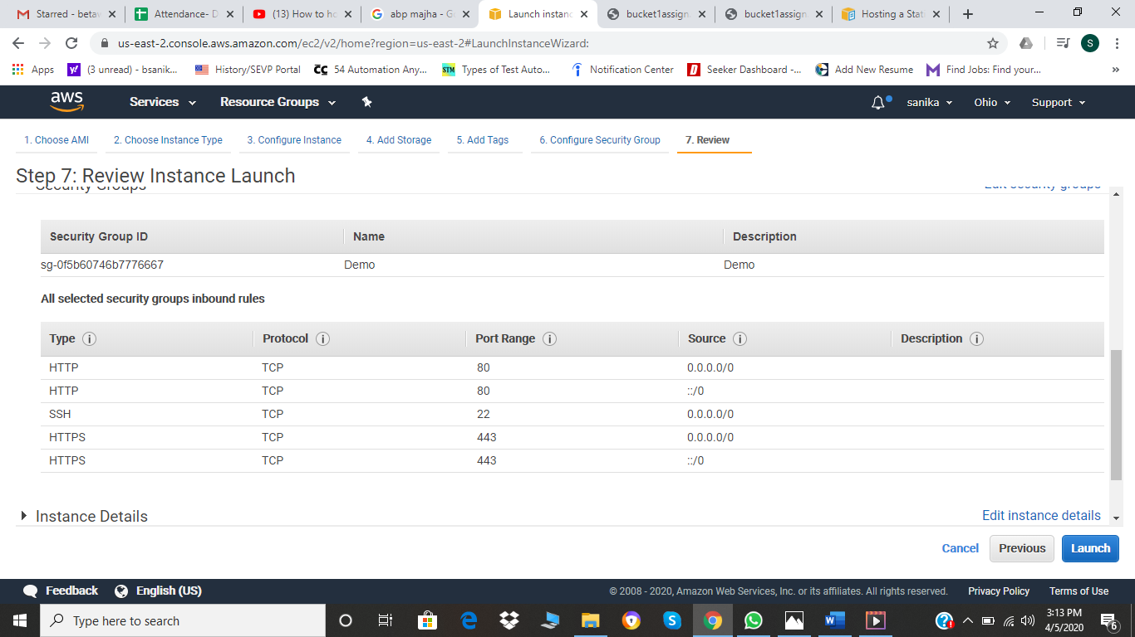

1. I have selected the already installed key pair.

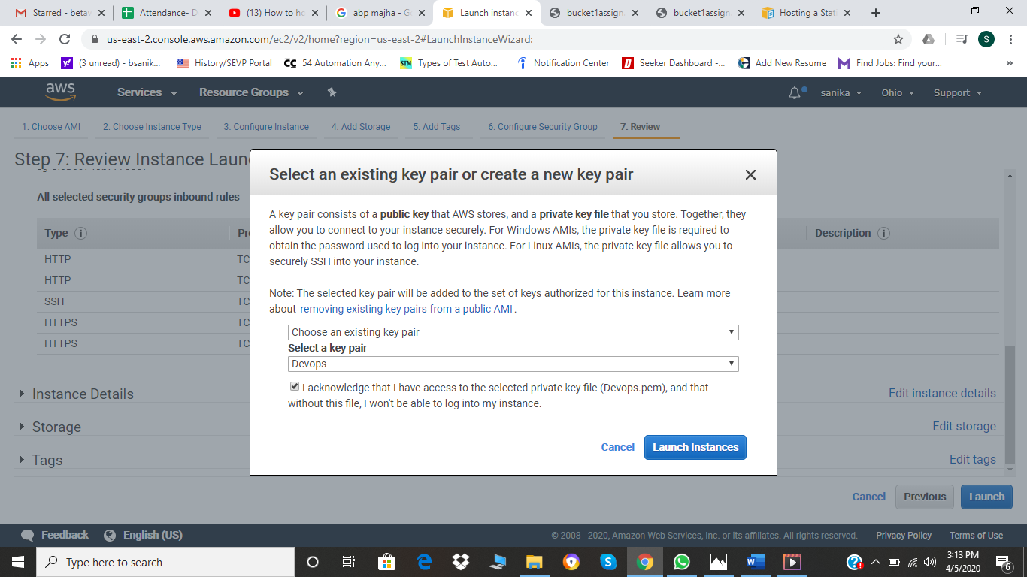

1. Launch instance

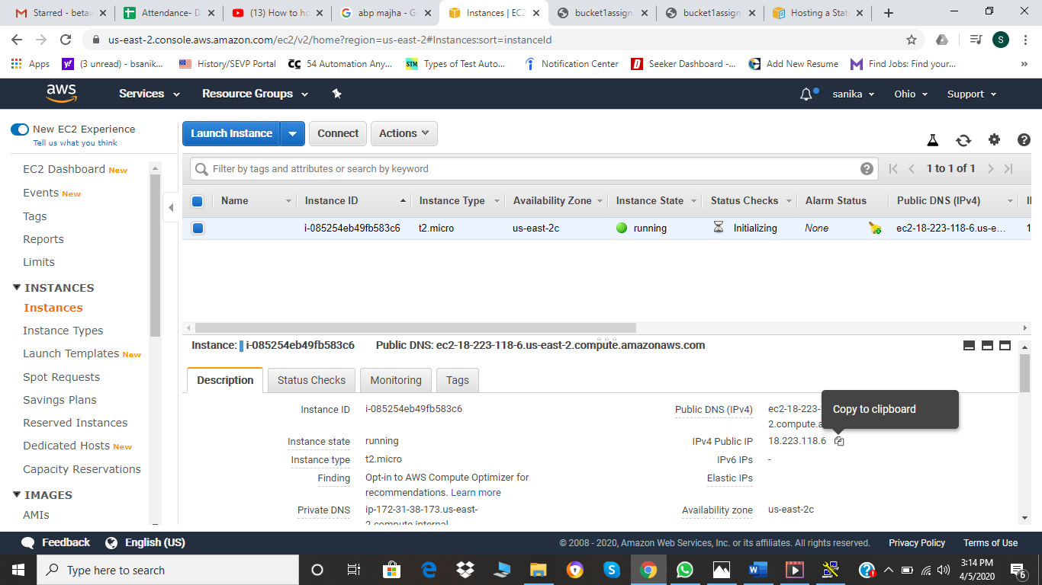

1. To I will be using putty gen to connect SSH server. With entering my public IP address and selecting the key pair. So, 1st image is of me entering the IP address.

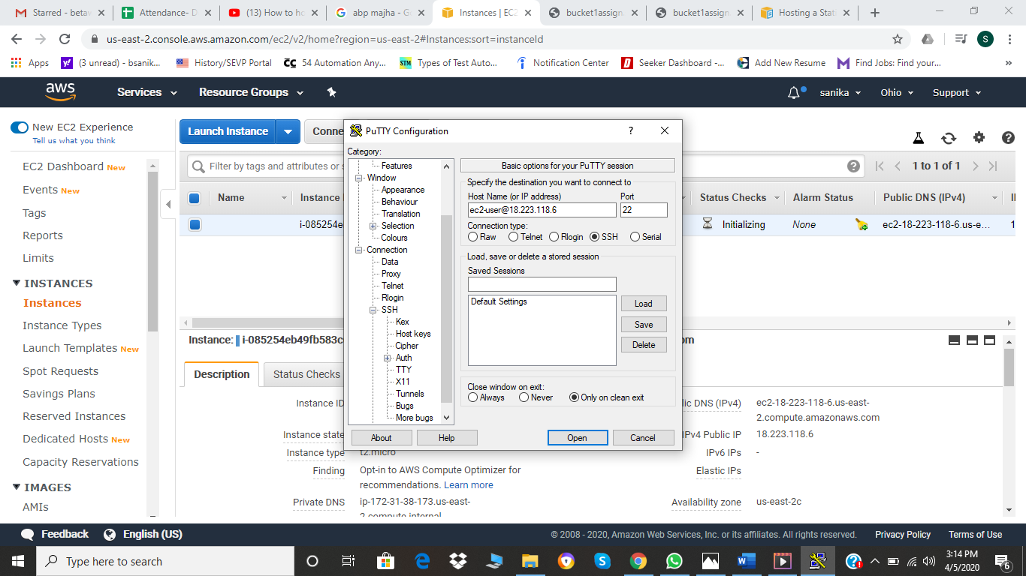

1. 2nd selecting the key pair for authenticating the SSH server. 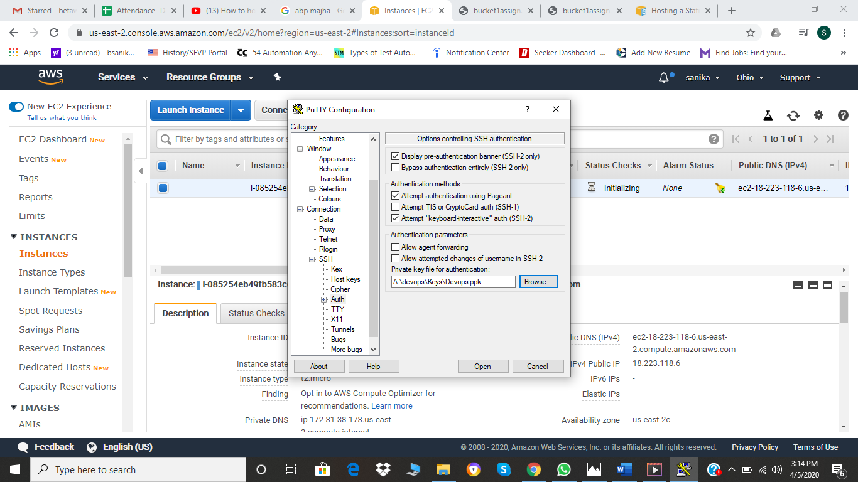
2. My putty is connected and my linux is installed and to use linux I just need to use “sudo yum update” which helps me to use the latest versions of linux. Where sudo is the super user , yum is the package and update is update.

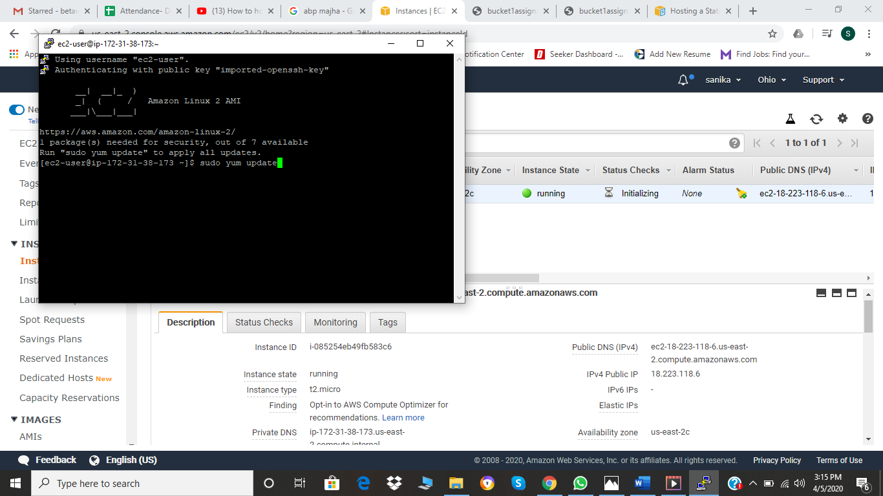

1. Now as I have use apache web service, the linux command is “sudo yum install httpd” and ‘-y’ is for the ‘yes’ as to complete the installation.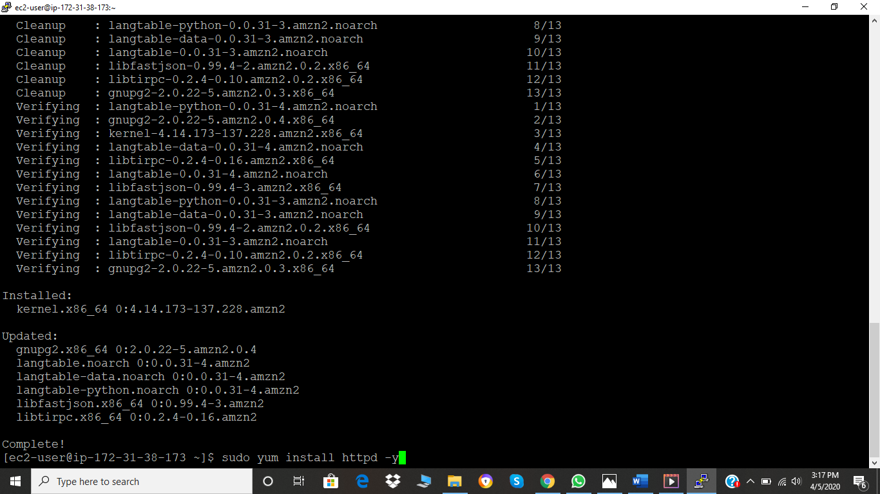
2. Now as we have installed the service we need to start it. Hence the command “sudo service httpd start”.

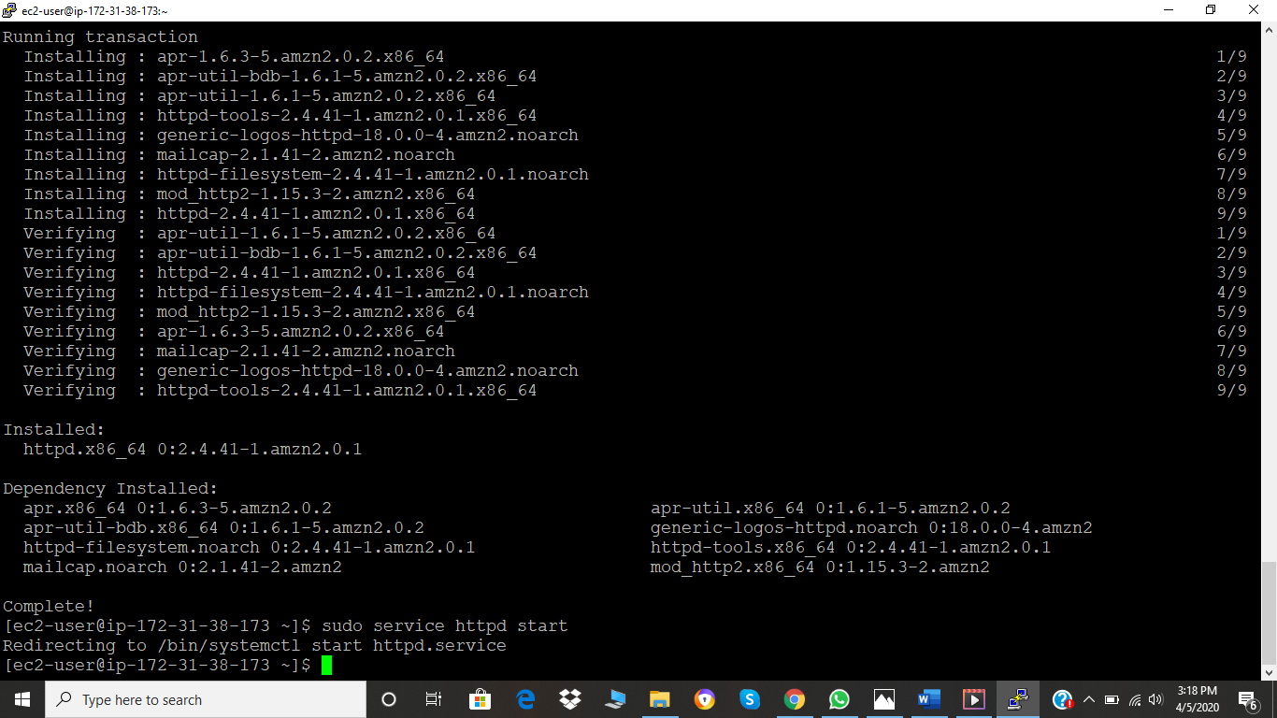

1. Now we need to check the status of the service , whether the service is active or not. Hence the command ,” sudo service httpd status” and it shows that the status is active.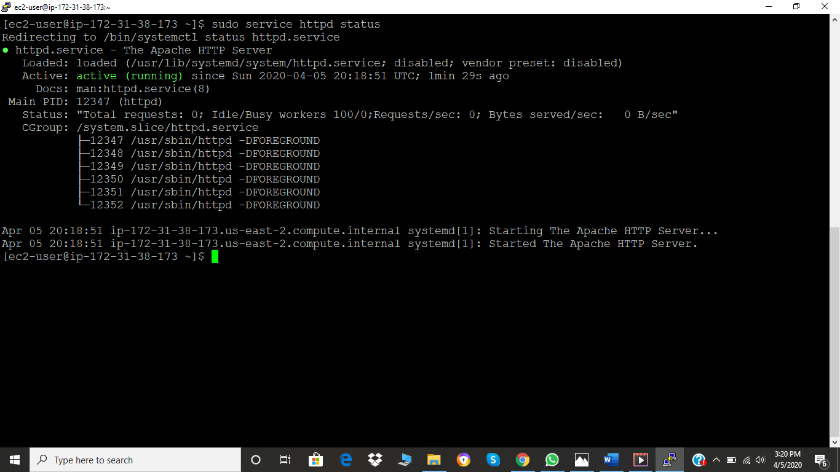
2. So I just went to the web page to check if it is working or not. For doing that I used the same IP address in my EC2 instance and copied it on my google chrome. So, it shows me the following webpage. It tells us that the web page is active and also shows the folder in which need to put our file so as to view on the webpage as the service is installed on linux. So we need to create folder as “ /var/www/html/”.

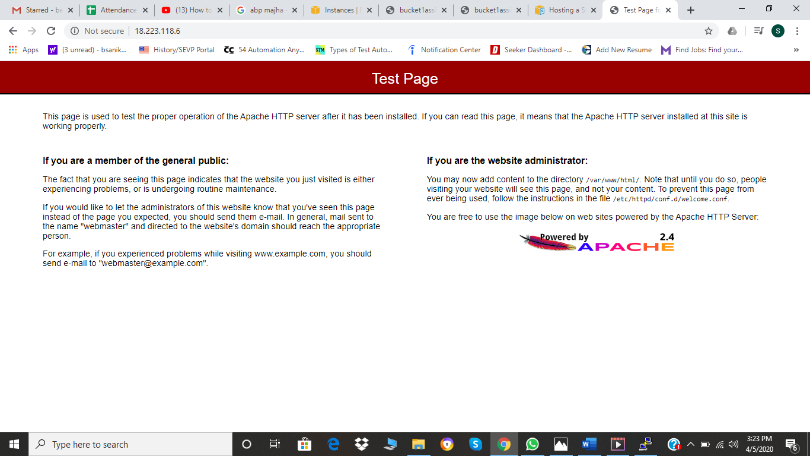

1. So I create a folder with the same name and for that suing linux command as “cd /var/www/html/”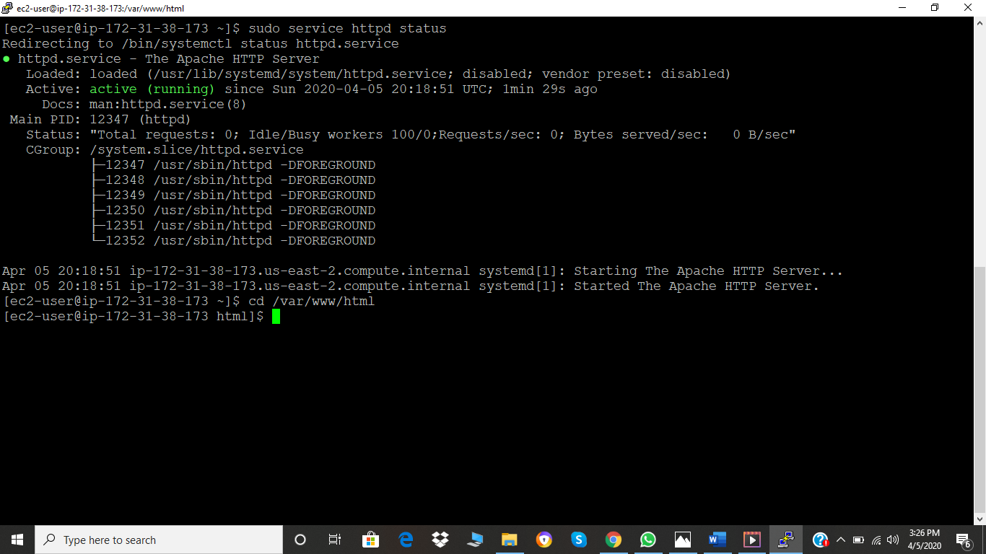
2. Then as I have to view my html page then I need to create my html file so I can either create it in linux using vi linux.html or use the same link which I used in my S3 bucket.so, I used the S3 bucket index.html link. I used linux command “sudo wget <http://bucket1assign.s3-website.us-east-2.amazonaws.com/index.html>”. Where wget means to download file for the internet. And my file is copied in the /var/www/html/ folder which can be shown by first going to the folder i.e “cd /var/www/html/ “ and then “ll” to list the files in that folder.

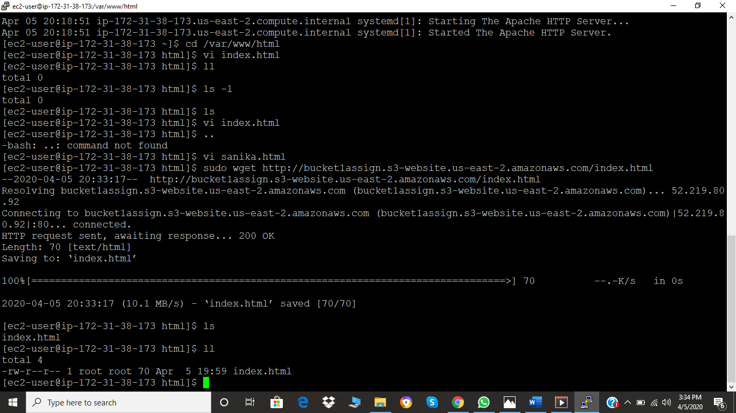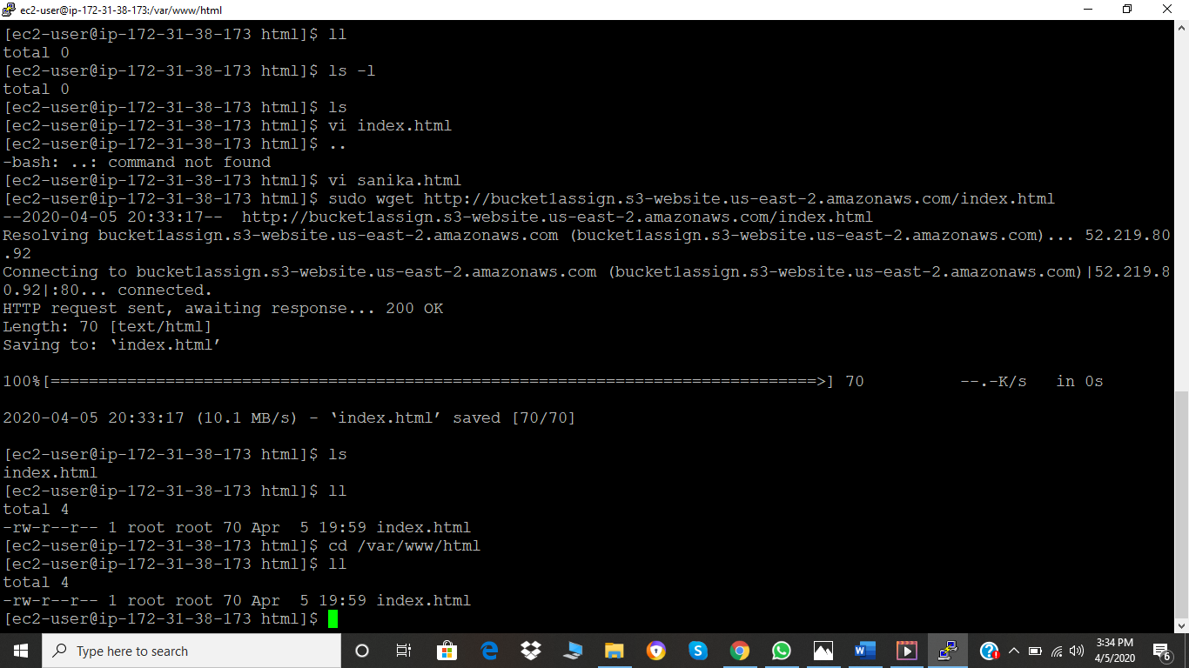

1. Finally as the file is created and copied in the specifies folder , we need to go to the website and just refresh it. And you get you “index.html” web page.

